Crime Prediction Using Machine Learning

¹Nidhi Singh M, ²Alidini Ajay Kumar Reddy, ²Betharasi Anand, ²Konjeti Naga Venkata Sai Himanth,

²Simham Nagasai
¹Assistant Professor, Department of Artificial Intelligence and Machine Learning, R L Jalappa institute of technology
Doddaballapur, Karnataka, India. ²Student,Department of Artificial Intelligence and Machine Learning, R L Jalappa institute of technology

ABSTRACT
Crime prediction has become a critical element of modern security systems because this approach enables the police to predict and prevent crimes, as opposed to just reacting to their occurrence. The conventional method of analyzing a crime is based on interpreting facts and has ineffective prediction mechanisms, especially where large data is involved.
In this manuscript, an intelligent crime prediction model using machine learning and deep learning techniques has been proposed to improve the prediction correctness. In the crime classification task, KNN, and other ensemble models like Random Forest, and XGBoost algorithms are used to recognize patterns in organized crime data. Moreover, an LSTM network has been adopted to analyze long-term trends in crime patterns.
Experimental outcomes show that the use of ensemble models and LSTM networks together helps achieve accuracy beyond the reach of standard machine learning solutions. A new developed solution helps gain valuable insights about the crime trends and the future crime patterns so that resources can be allocated in an efficient manner for the law enforcement agencies.
Keywords: Crime Prediction, Machine Learning, Ensemble Models, LSTM, Time-Series Analysis.

INTRODUCTION

Crime is one of the most serious factors that threaten citizens' safety, economic development, and the improvement of people's livelihoods. The rapid growth in urbanization and mobility accelerates criminal activities. Crime data from records, surveillance, and public reporting systems mounts pressure on the law enforcement agencies to develop ingenious and workable ways of handling the ever-increasing volumes. Traditional methods of crime analysis are mostly done manually and retrospectively; therefore, they are inefficient in mining predictive patterns from a large volume of data.

Conventional methods of crime analysis rely predominantly on descriptive statistics, examination of past trends, and so on. While these methods are helpful to understand the crimes that happened in the past, they do not provide significant assistance in predicting future crime patterns. Because of this, policing strategies tend to be reactive in nature and thus slow, at best, and inefficient in deploying scarce resources. With the increasing availability of digitized data about crimes, it is now apt to move toward intelligent, data-driven crime prediction systems.

Recent breakthroughs in machine learning have empowered the analysis of complex data by recognizing hidden patterns and nonlinear relationships among different variables such as location, time, and crime type. Various methods of ensemble learning incorporate several learners to robustify and reduce overfitting, including Random Forest and gradient boosting algorithms; thus, giving very good results. These methods are extremely useful in crime classification tasks with diverse and

imbalanced datasets.

Apart from the spatial and categorical patterns in crime data, strong temporal characteristics influenced by seasonal social and economic factors are evident. Deep learning models, particularly Long Short-Term Memory networks, will be more appropriate for modeling such sequential data because they are designed to keep long-term dependencies. This paper investigates a hybrid crime prediction framework that is able to combine ensemble machine learning models in crime classification with LSTM-based forecast for temporal prediction. This will enhance predictive accuracy and provide actionable insights supportive of proactive policing and strategic public safety planning.

RELATED WORK

Crime prediction has received considerable attention from researchers because of its ability to improve public safety by making decisions based on data analysis. Many researchers have examined the capabilities of data mining algorithms and deep learning algorithms in analyzing crime occurrences and making predictions.
Sathyadevan et al. [1] created a method of analyzing crime based on data mining concepts that could be applied to historical data of crime patterns. The method was designed to detect patterns of crime through classification based on time and location attributes. The method was able to provide accurate predictions concerning crime patterns, but there were no means of analyzing long-term patterns of time dependencies.
A study by Gupta & Jain [2] explored the application of machine learning algorithms like Decision Trees & Naïve Bayes for classifying & predicting crimes. The authors succeeded in their endeavor to classify accurately, though their method had limitations when it came to predicting long-term trends of crimes as it could not incorporate temporal perspectives.
Authors Mishra et al. in [3] introduced a hotspot prediction model that was based on clustering and classification. K-Means clustering algorithm was adopted to detect hotspots, and the classification algorithm was based on the Random Forest classifier. The model gave an excellent location perspective but was moderately accurate in time-based predictions.
Keyvanpour et al. in [4] proposed an integrated crime prediction model with a focus on feature selection and data preprocessing. Although this solution produced acceptable results, the model was highly dependent on manual feature development.
Deepak Kumar et al. in [5] investigated the use of ensemble learning methods like Random Forest, Gradient Boosting, etc., for better accuracy in crime classifications. The experiment confirmed the effectiveness of ensemble methods in dealing with complex datasets, but the issue of crime patterns in time is not discussed.
This problem was addressed by Verma et al. in their paper on predicting crimes. The researchers employed Support Vector Machines and Random Forest algorithms in predicting the types as well as the places where crimes will happen. This prediction system proved to be effective in predicting common types of crimes but lacked effectiveness in predicting rare crimes.
In applying conventional time series analysis methods for crime forecasting, the importance of including features such as month and year was highlighted in [7]. They have, however, not been very successful at modeling intricacies tied to long-range dependencies that exist within crime data.
A study by Singh et al. [8] used LSTM networks to capture the temporal dependencies in the crime data. The study utilized the power of Deep Learning and was able to produce forecasts that significantly outperformed the forecasts of traditional Machine Learning models, even though a large amount of data was needed.
Hybrid models, that is, the integration of machine learning concepts with those of deep learning, have also been considered. Hassan et al. in [9] developed an approach that combined ensemble classifiers along with an LSTM model for better prediction.
Likewise, Aishwarya et al. in [10] developed an approach for real-time crime prediction that had optimal computation cost, but upon analyzing large data, it had limitations.
Mandalapu, V., Elluri, L., Vyas, P., & Roy, N.[11] (2023).Crime prediction using machine learning and deep learning: A systematic review and future directions. IEEE Access, 11, 60153–60179.
[12] Zhang, X., Liu, L., Xiao, L., & Ji, J. (2020). Comparison of machine learning algorithms for predicting crime hotspots. IEEE Access, 8, 170383–170394.
[13] Safat, W., Asghar, S., & Gillani, S. A. (2021). Empirical analysis for crime prediction and forecasting using machine learning and deep learning techniques. IEEE Access, 9, 70080–70094.
[14] Meenakshi Sundaram, S., Sivakumar, P., Parthiban, M., & U. Revathy (2022).Crime hotspot analysis using six layered deep recurrent neural networks. International Journal of Early Childhood Special Education (INT-JECSE), 14(14), 508–520.

- PROPOSED MODEL
The proposed model presents an effective platform for intelligent crime prediction that creates synergy between Machine Learning and Deep Learning approaches. The central idea of this model is to effectively translate historical raw data to intelligence that would help law enforcement organizations switch to proactive approaches from their current reactive approach. The model is designed on two strong and fundamental foundations: data preprocessing, classification through ensemble approaches, and time-series predictions through LSTM Networks.

Data Acquisition and Preprocessing
The data acquisition phase entails the consumption of crime data from trusted sources, which entails essential features such as crime categories, geographic information, timing, and crime rate. Data preprocessing is utilized to assure the integrity of the model. It entails handling missing values through imputation techniques, noise elimination, and the normalization of numeric features. Additionally, feature preprocessing is used to convert categorical features into appropriate formats for model implementation. It also entails feature engineering to tap into minute temporal patterns like day and seasonality features that are crucial in providing an insight into cyclic patterns.

Classification Module
To address the problem of crime classification, our module adopts a multi-level solution. KNN acts as the baseline method that establishes correspondences between data similarities based on local distributions. Yet for optimizing classification performance and promoting data generalizability, our module primarily utilizes ensemble learning strategies: Random Forest classification and the powerful abilities of the XGBoost method. As mentioned above, combining the classifiers of multiple trees aids in addressing overfitting challenges in data classification related to crime statistics.

Forecasting Module
To address the issue of timing in crime, the prediction of when events tend to happen, the model uses Deep Learning through an LSTM network. Contrary to traditional regression models, an LSTM network is optimized to address sequential patterns within data, making them expressly better suited to understanding long-term patterns in crime through the utilization of “memory.” Through this, the model converts crime data to temporal patterns, utilizing the LSTM network to forecast future crime levels.
Evaluation and Impact For assessing the efficiency of the developed model, different parameters such as accuracy, precision, recall, and F1-score are used. With the developed system, law enforcements not only get a prediction system but also a scalable solution. The system allows the law enforcements to get a clear visual representation of the dangers, thereby increasing the accuracy of resource distribution for crime prevention.

System Overview
The crime prediction framework proposed is a representation of extensive, analytics-based approach that seeks to change raw historical records into actionable intelligence. By combining machine learning for classification with deep learning for time series forecasting, the resulting system enables law enforcement agencies to move from reactive strategies to proactive safety management. The architecture itself is based on four unique but Interconnected Modules:
1.Data Acquisition & Preprocessing Module The first step for this system to handle is data acquisition. Data for past crimes will be accumulated from authoritative sources like the police department database. Raw data consists of important parameters like the nature of the crime, location, time, and crime frequency. But real-world data might be erroneous, incomplete, or inconsistent.
This module ensures integrity of the model by conducting thorough cleaning and data transformation. Major processes involved in this step are:
Imputation: Missing value treatment for analysis continuity.
Deduplication: Deletion of Rep
Encoding & Normalization: Both encoding of nonnumerical variables (e.g., crime category) and scaling of other attributes are needed for algorithm equality.
Feature Engineering: Creation of granular time features like particular days, months, or year features to identify cyclical patterns.
2. Crime Classification Module The crime data is now ready to move to the classification phase, which identifies the likely crime to be committed because of geographical and attribute data. We use a multi-tiered strategy:
Baseline Analysis: The K-Nearest Neighbors (KNN) algorithm is used to baseline how similar or how well-distributed crime data is.
Ensemble Learning: To obtain maximum accuracy and robustness, the developed system uses the latest ensemble models, namely Random Forest and XGBoost. By combining the reasoning of varied decision trees, the developed models can overcome the challenge of overfitting and learn the inherent non-linear relationships in the crime data.
3. Crime Forecasting Module Simultaneously running is the forecasting module, whose task is to predict times of possible crimes. The module employs the use of a Long Short-Term Memory network, a deep neural network that has some specificity to its design. The input data is rearranged into various time series formats so that the network can learn from past patterns within a sequence. The network is ideal because of its memory cell design that is better suited to capture long patterns, such as seasonal variations and trending of crime over time.
4. Evaluation and Output Module The final component is the validation and output layer. This component critically evaluates the performance of the models on predefined metrics such as accuracy, precision, recall, and F1 score. The last output will be a set of insights for predicting the type of crimes likely to happen as well as the future rate at which they will happen. This will be a decision-making component for the concerned authorities. This module also has a scalable architecture.
data similarity and distribution. Subsequently, ensemble models like Random Forest and XGBoost are employed in order to enhance classification accuracy. These models are efficient in dealing with non-linear data, particularly in crime data. They identify hidden patterns in licensed businesses.
Simultaneously, the time series forecasting component applies a Long Short-Term Memory (LSTM) Neural Network model in order to predict future trends in crimes. Due to the temporal nature of the crime dataset, historical crime records are grouped in sequencing that can be processed by the time series model. Finally, the result of prediction obtained from both the classification as well as prediction modules is measured by using generally defined standards like accuracy, precision, recall, as well as F1 measures. The system produces effective outputs in terms of predictions for different types of crimes as well as predictions for the trends of crimes to be committed in the coming periods. This system can be considered scalable, efficient, as well as effective for handling larger datasets of crimes.

METHODOLOGY

This section details the systematic approach followed to design and implement the proposed crime prediction system. The methodology covers data acquisition, preprocessing, feature engineering, model training, and performance evaluation using machine learning and deep learning techniques.
1. Data Collection
Historical crime data forms the basis of the proposed system. Reliable sources of datasets were retrieved from open public sources and government sources, such as online repositories and law enforcement databases. Each record retained important attributes relevant to the crime type, geographical location, date, time, and frequency of occurrence. These records are used for ground truth needed for the training and validation of predictive models.
2. Preprocessing of Data
Real-world data can be prone to having irrelevant values, duplication of records, and inconsistencies in values, affecting the model performance. For that, preprocessing techniques such as removal of duplicate entries, handling missing values using statistical imputation, and elimination of noisy or irrelevant data were employed. This step ensures that there is reliability in the consistency of the dataset.

3. Feature Engineering & Encoding
After cleaning, the dataset is transformed into a format suitable for computational models. Features of time include hour of the day, day of the week, month, and season that are extracted from timestamp data to catch the pattern of crime with respect to time. Spatial attributes are encoded to represent larger geographic regions, while categorical variables such as crime type are transformed into numerical variables using methods like label encoding or one-hot encoding. Numerical features are normalized to maintain uniformity across different scales.
4. Classification of Crime
Crime classification can be done to predict the category of crimes based on historical patterns. In order to improve the reliability of the results, multiple models are used. K-Nearest Neighbors algorithm serves as the baseline algorithm and computes similarity within data points. To improve the classification accuracy and generalize well, ensemble learning models such as Random Forest and XGBoost are used. These models make use of several decision trees in order to capture nonlinearity in the data with a reduced risk of overfitting.
5. Time Series Crime Forecasting
This model employs an LSTM network for the forecasting of future crime trends. Temporal dependencies can be learned by a model trained on data structured in sequential, time-series format. Accordingly, this LSTM architecture is expected to perform well on capturing long-term and seasonal trends in criminal activities, enabling it to provide better forecasts of future crime rates.
6. Model Evaluation
These are supported through metrics like accuracy, precision, recall, and F1-score. In the case of the forecasting module, the evaluation metrics for prediction accuracy could consider MAE and RMSE. These metrics ensure that the system produces reliable and meaningful predictions suitable for practical deployment. 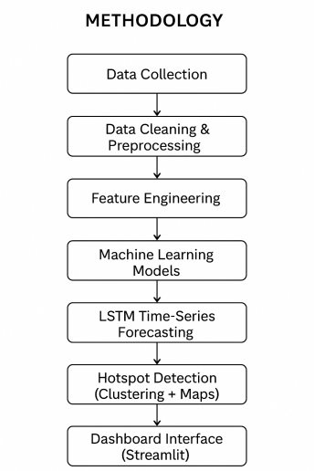
Work Flow Summary:
1.Data Foundation, (Acquisition & Preparation)
The process begins with the Collection of Historical Crime Data, as this data constitutes the ground truth for the entire system. However, since real-world data is usually noisy, it passes through a stage called ‘Pre-processing’ in order to remove inaccuracies by removing duplicates, handling missing values, and ensuring that models are developed for efficient decision-making through high-quality information.
2. Feature Engineering
After being cleaned, the data is subjected to the Feature Extraction and Encoding phase. It is at this phase that the data attributes are converted to forms that computers can read. Categorical variables such as types of crime or zones are converted to numerical variables, as are the values for day, month, or season that have to be converted to facilitate the computation of time-related patterns.
3. Dual-Stream Intelligent Analysis
The central processing task is split into two streams:
Crime Classification: For categorizing what sort of crime might happen, it leverages a highly effective blend of algorithms. K-Nearest Neighbors (KNN) is used as a benchmark for calculating similarity, whereas sophisticated ensemble algorithms such as Random Forest and XGBoost are used for dealing with intricate, nonlinear relationships.
Time Series Forecasting: On the other hand, in order to determine the periods when the crime rates may exceed, the design uses LSTM (Long Short-Term Memory) networks. This is a part of the AI solution that uses the data to provide forecasts of future trends.
4. Validation and Output
The final stage entails Model Evaluation based on performance metrics (Accuracy, Precision, Recall, and F1-Score) to ensure that the predictions made (Classification of crime types and Trend prediction) are statistically valid before being used for decision-making purposes by the law enforcement agencies.
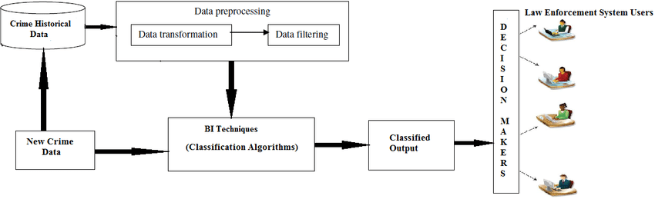
Data Collection Process
The data gathering phase is actually the backbone on which this crime prediction model is designed. Given that the quality of any AI model is highly dependent on the data fed to this model, we made sure to obtain high-quality data from law enforcement agencies and other research platforms.
Discussion of the Data
What the Data
The dataset is constructed based on organized records of distinct events of crimes. To allow the models to form an understanding of what exactly is happening, where, and when, each record contains:
•Type of Crime: (e.g. Theft, Assault
•Location: This is where the event occurred.
•Timestamp: The actual date and time.
•Frequency: Similar events occur with what frequency in this region.
Identifying Patterns in Time Series Datasets
Our system requires data spread over a number of years to ensure that the system does not identify 'snapshots' but instead identifies trends. The reason for this is that it is crucial for the LSTM networks to be able to identify the patterns so that accurate predictions for the future can be made.
Privacy and Ethics
Data integrity: This requires not only accuracy but responsibility as well. We made certain that all data was fully anonymized. There was no mention of names, specific addresses, or other identifying information. This was purely for academic purposes, based on trends for public safety.
Preparation for Analysis
However, After being extracted, this data was structured in a common form (such as CSV). We further performed initial screening in an attempt to point out any missing or duplicate entries so that our data was ready for processing-modeling.
Final Dataset Preparation
1. "Deep Clean
Prior to doing the analysis, we had to clean the data. This included:
•Managing Missing Information: We applied imputation methods to replace missing or remove incomplete data where necessary to ensure that the model did not learn inappropriate bias information.
•Removing Duplicates. We eliminated all duplicates from being considered, so that certain events were not inadvertently given 'extra weight' by the model.
•Filtering Noise: The irrelevant information that wasn't useful in making predictions about crimes was removed, leaving the most influential information.
2. Translation & Scaling
Algorithms do not read words but numbers. In the attempt to fill this gap, two approaches have been employed:
•Encoding: We encoded categories such as "Crime Type" or "Location Name" to numerical values.
• Normalization: All numerical variables have been normalized to have the same scale. It helps to counter the effect that could result in an insignificant variable becoming too important due to its large number compared to another significant variable such as the time of the day in the case of the zip codes.
3. Structuring for Time-Series Analysis
Because our system is built using LSTM (Long Short-Term Memory) networks, time treatment is essential in our system.
•We extracted dates by breaking it down into individual properties: Day, Month, and Year. * After that, it was necessary to implement this data in a sequential fashion so that it is visible to the model itself and ‘sees’ it in that order. It is this that makes it possible to ‘understand’ the concept of temporality, such that, perhaps, there is an increase in certain crimes that take place during holidays or seasons.
4. The Final Split: Training vs. Testing
In order to ensure that the system truly works well in the real world and is more than just "memorizing" history, we split the final data set into two:
•The Training Set: It is used to train the models on patterns and trends.
•Testing Set: To be kept distinct and utilized as a 'final exam', testing how effectively the developed model can predict the crime on unseen data.
The Result: A well-structured and normalized high-quality dataset that is a perfect engine for crime classification and prediction.
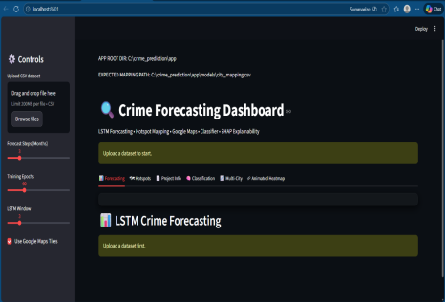

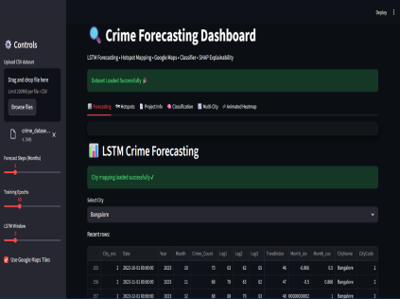
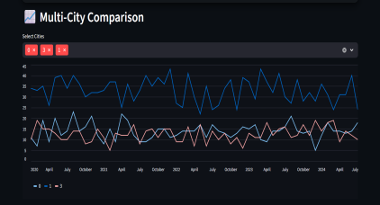
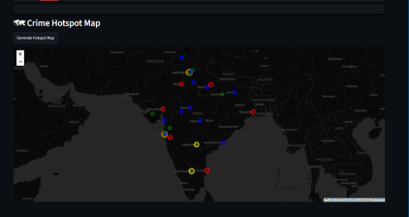
Dataset Description
The crime dataset employed for this analysis contains structured crime data collected in India over several years to facilitate crime analysis and prediction by machine learning algorithms and deep learning algorithms. The dataset is comprised of tens of thousands of instances, wherein every instance is a crime event that has been reported, and has associated temporal and spatial attributes along with category fields.
The major characteristics in the dataset are type of crime, location information like state/district where the incident took place, date of the incident, and time. These characteristics allow for the examination of crime trends in a particular area as well as at a particular time. Other time-related characteristics like year, month, date, and hour have been extracted from the date and time fields.
During the preprocessing phase, missing and inconstant values in the dataset are dealt with using the relevant techniques to ensure the quality of the data. Categorical variables, such as the type of crime and the location, are encoded in a number using label encoding and one-hot techniques, as required by the machine learning algorithm. Numerical variables are normalized.
The data was split into training and test datasets, preferably with an 80:20 split, to ensure fair model evaluation. The training data was then utilized to train models to identify crime patterns, while test data was to test the accuracy levels of predictions. The crime data offered seems to have sufficient efficacy to provide a good base to establish crime prediction models using machine learning algorithms such as Random Forest, Support Vector Machine, or even deep learning networks such as LSTM models. The data seems to have adequate structure to analyze crime trends, which can then easily predict future crime events.
SYSTEM DESIGN
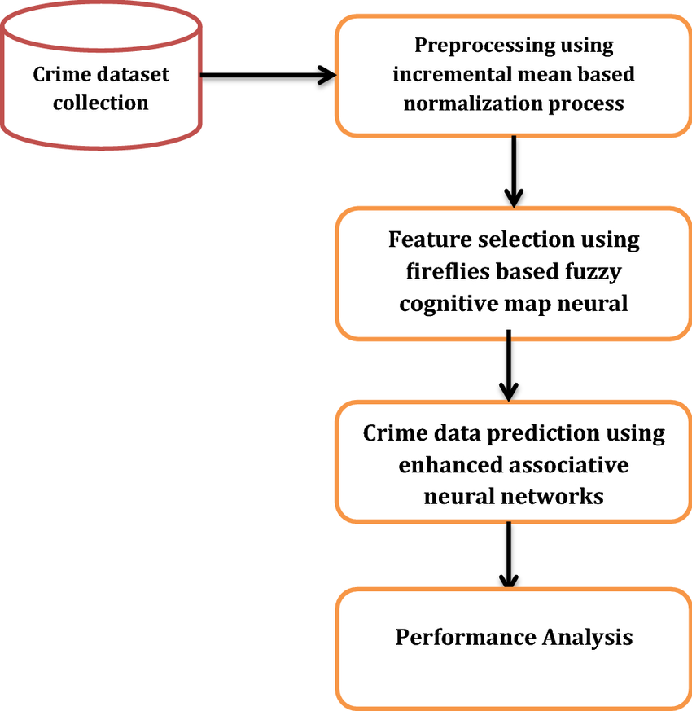

1. Layers of Data Input & Preprocessing
The Data Input Layer is the very foundation of this system, and works to ingest historical crime data in the form of CSVs or databases, which include the crime types, their locations, and their timestamps.
The Preprocessing Layer works like a filter because raw data is never perfect. It removes duplicates, fills in missing values, and normalizes numbers. Importantly, it also handles "data balancing," which means it ensures the model won't get biased toward common crimes and ignore the rarer ones that are more serious.
2. Feature Engineering Layer
This layer provides the "translation." It takes raw timestamps and breaks them down into specific Temporal Features such as the day of the week, the month, or even specific time intervals. This is crucial to be comprehended by the forecasting module in order to understand "when" crimes are most likely to take place, such as spikes during holidays or weekends.
3. "Brain": Classification & Forecasting Modules
The system analyzes crime on a two-pronged approach:
Classify Crime - "What": The system classifies incidents using models like Random Forest and XGBoost. While KNN serves as a baseline, these ensemble models are the ones that provide the heavy lifting in combining multiple paths of decision-making to an even more accurate conclusion.
• Crime Forecasting (The "When"): For this module, which employs an LSTM network, LSTMs are deep learning models that have the ability to memorize previous trends; hence, they are ideal for predicting future crime frequencies and seasonal fluctuations.
4. Application Layers of Evaluation & Visualization
Before the results are final, these models are taken to task by the Evaluation Module. We consider not just Accuracy but also Precision, Recall, and F1-scores so that the system is reliable for all categories of crimes.
Finally, the Output & Visualization Layer converts involved math into clear insights. It allows law enforcement agencies to practically take advantage of predicted crime categories and trend charts in strategic planning.
Why This Design Works
• Modularity: AI models can be updated without having to rebuild the entire data pipeline.
• Scalable: It is designed to bear loads of data from multiple cities or regions.
•Actionable: It goes beyond simple "data points" into proactive, data-driven strategies on public safety.
CONCLUSION
In this research, an intelligent crime prediction model was offered by applying machine learning and deep learning approaches synergistically for analyzing past Crime Data and projecting future Crime Patterns. By integrating Ensemble Classification Models with Time Series Forecasts employing Long Short-Term Memory Networks, this model was capable of identifying both spatial and temporal patterns of the Crime Data.
Through experimental evaluation, the result showed that the baseline methods, K-Nearest Neighbors, were not effective for dealing with complex and large-scale datasets, but the Random Forest, XGBoost, and LSTM-based methods produced better results as they are capable of dealing with nonlinear problems and preventing overfitting. In addition, the LSTM-based model used for making predictions was effective as it captured overall seasonal changes, hence providing effective predictions for the trend of the crime rates.
The robust framework also helps in making well-informed decisions. It does this through the delivery of insights that help in the planning and resource allocation processes in law enforcement institutions. The modularity of the approach also enables the extension of the system to cover larger datasets and wider regions.
Though the model in the proposed system is highly predictive in capability, its functionality is still linked to the quality and availability of the historical data. It is quite hard to predict crime occurrences that are rare in nature. Future development may be based on the use of real-time data streams and may incorporate various sophisticated models based on deep learning in order to enhance predictive capability. The proposed system emphasizes the application of data-driven intelligence to improve proactive crime preventions and management of public safety.
REFERENCES
[1] K. Sathyadevan et al. proposed a crime analysis and prediction system that utilizes data mining techniques on historical crime data. The work focused on identifying crime patterns based on location and time using classification algorithms. The proposed system demonstrated an improved prediction accuracy for structured datasets but limited in handling temporal dependencies.
[2] A. Gupta and R. Jain proposed a model of crime prediction based on the machine learning algorithms Decision Trees and Naïve Bayes. For this model, it is observed that with the help of some analysis of records of crimes, the system could classify the type of crimes and predict them in the future. The performance results indicated its best performance in the classification task, but it is not strong enough to present correct forecasts of long-range crime trends.
[3] S. Mishra et al. proposed a framework for crime hotspot prediction using clustering and classification techniques. The system utilized K-Means clustering to identify crime-prone regions and performed classification using Random Forest. The results exhibited a very effective spatial analysis of the crime, but the accuracy regarding time prediction was found to remain moderate.
[4] M. R. Keyvanpour et al. proposed an integrated crime prediction method using both data mining and machine learning. In this work, the author highlighted feature selection and preprocessing to enhance model performance. The developed system has reached reasonable results, but its development needs exhaustive manual feature engineering.
The paper "Crime Prediction using Ensemble Learning" by Deepak Kumar et al. proposed a crime prediction model using ensemble learning techniques including random forests and gradient boosting. Their model significantly improved the classification performance by ensembling multiple decision trees. However, the time-series crime patterns have not been captured in an explicit manner.
[6] Harshita Verma et al. proposed a crime prediction system that utilized Support Vector Machines and Random Forest algorithms. The system employed historical crime data to forecast categories and locations of crimes. Results showed a high accuracy on the known patterns of crimes but a reduced performance in the case of rare types of crimes.
[7] R. K. Sharma et al. proposed a crime forecasting model by analyzing the criminal activities using time-series analysis. Their method identified that month and year can be considered as important temporal features in predicting the criminal trends, while in practice, traditional methods of time-series failed in capturing the complex long-term dependencies.
It presented a deep learning-based crime prediction system, P. Singh et al. introduced a deep learning-based crime prediction system using Long Short-Term Memory (LSTM) networks. This model was successful in extracting the temporal dependencies of the data in crime incidents and thus provided better performance with regards to accuracy in forecasting than traditional machine learning techniques. The limitation of this approach was its requirement for large training datasets.
Mona Hassan et al. proposed a hybrid crime prediction system that used the combination of machine learning classification and deep learning-based forecasting. In their work, they have introduced an integrated ensemble model with LSTM for time series-based prediction, which resulted in higher accuracy. Their results have proved that hybrid models work more effectively in crime prediction.
[10] Aishwarya R. et al proposed a real-time crime prediction architecture using machine learning models to minimize computational cost. The proposed technique works well with the urban crime datasets, whereas when applied to complex ones with large-scale information, the model produces lesser accuracy.
[11] Mandalapu, V., Elluri, L., Vyas, P., & Roy, N. (2023). Crime prediction using machine learning and deep learning: A systematic review and future directions. IEEE Access, 11, 60153–60179. https://doi.org/10.1109/ACCESS.2023.3286384
[12] Zhang, X., Liu, L., Xiao, L., & Ji, J. (2020). Comparison of machine learning algorithms for predicting crime hotspots. IEEE Access, 8, 170383–170394. https://doi.org/10.1109/ACCESS.2020.3026420
[13] Safat, W., Asghar, S., & Gillani, S. A. (2021). Empirical analysis for crime prediction and forecasting using machine learning and deep learning techniques. IEEE Access, 9, 70080 70094. https://doi.org/10.1109/ACCESS.2021.3078817
[14] Meenakshi Sundaram, S., Sivakumar, P., Parthiban, M., & U. Revathy (2022). Crime hotspot analysis using six layered deep recurrent neural networks. International Journal of Early Childhood Special Education, 14(14), 508–520. https://doi.org/10.48047/INTJECSE/V14I8.309

